**4.5 Introduction to the Programming Language Python and the application Jupyter Notebooks**

**Reading material**

|  |
| --- |
| Introduction to the Programming Language Python and the application Jupyter Notebooks  Get ready, this is getting interesting!  Since this is a course on machine learning, we will start this session with the programming languages Python and the application JupyterLab. Python's expansive library of open-source data analysis tools, web frameworks, and testing instruments make its ecosystem one of the largest out of any programming community. Python is an accessible language for new programmers because the community provides many introductory resources.  You will use Python and JupyterLab as one of the technologies that enables interactive computing and you will also use them later in the course for developing your own project in Module 10 and Module 11.  Why is this relevant for you in the frame of this course? Well, next steps to be performed for Earth Observation will need the Python programming language and JupyterLab because they are mostly cloud based. During the course, we are mainly going to use Sentinel Hub as an EO Processing Platform. Before we register you on Sentinel Hub, it is important that you get introduced to Python and Jupyter Notebook.  Ready? Then first read the following background material on Python, Jupyter Notebook, and then download the instruction file to install these programmes. |
| **What is Python?**  Python is a popular programming language. It was created by Guido van Rossum, and released in 1991. It is a dynamic programming language which supports several different programming paradigms:   * Procedural programming * Object oriented programming * Functional programming |
| **What is it used for?**  **Python is used for…**   * web development (server-side), * software development, * mathematics, * system scripting. |
| **What can Python do?**   * Python can be used on a server to create web applications. * Python can be used alongside software to create workflows. * Python can connect to database systems. It can also read and modify files. * Python can be used to handle big data and perform complex mathematics. * Python can be used for rapid prototyping, or for production-ready software development. |
| **Why Python?**   * Python works on different platforms (Windows, Mac, Linux, Raspberry Pi, etc.). * Python has a simple syntax similar to the English language. * Python has syntax that allows developers to write programs with fewer lines than some other programming languages. * Python runs on an interpreter system, meaning that code can be executed as soon as it is written. This means that prototyping can be very quick.   Python can be treated in a procedural, an object-oriented or a functional way. |
| **Python Syntax compared to other programming languages**   * Python was designed for readability and has some similarities to the English language with influence from mathematics. * Python uses new lines to complete a command, as opposed to other programming languages which often use semicolons or parentheses. * Python relies on indentation, using whitespace, to define scope, such as the scope of loops, functions and classes. Other programming languages often use curly brackets for this purpose. |
| Introduction to Jupyter Notebook and JupyterLabProject Jupyter Project Jupyter is a project and community whose goal is to develop open-source software, open-standards, and services for interactive computing across dozens of programming languages. It is possible to run it over 70 different programming languages. The project was born out of the IPython Project in 2014. The name “Jupyter” is a combination of the programming languages “Julia”, “Python”, and “R”. |
| Project Jupyter has developed and supported the interactive computing products Jupyter Notebook, JupyterHub, and JupyterLab:   1. **Jupyter Notebook**: A browser-based application that allows you to create and share documents (i.e., Jupyter Notebook files) that contain live code, equations, visualizations, and narrative text. The Jupyter Notebook file format is “.ipynb”, which is short for “interactive python notebook”. 2. **JupyterLab**: A browser-based application that allows you to access multiple Jupyter Notebook files as well as other code and data files. It is a new version of Jupyter Notebook that includes Notebook, text editor, console and a file explorer. 3. **JupyterHub**: A multi-person version of Jupyter Notebook and Lab that can be run on a server. It is an encapsulated environment for multiple users.  Link to Jupyter: <https://jupyter.org/> |
| Why Jupyter Notebook?  * It is easy to use * It provides a single document that combines explanations with executable code and its output * It is easy to share * It allows to write and run code interactively * An ideal way to provide:   1. reproducible research results   2. documentation of processes   3. instructions   4. tutorials and training materials |
| * Jupyter Notebook is very easy to use -it only consists of a file browser and an editor view. * JupyterLab is the next generation of the Jupyter Notebook. It has a more complicated user interface, however, with more capabilities. * Using JupyterLab, you can open several notebooks or files (e.g., HTML, Text, Markdowns, etc.) as tabs in the same window. * JupyterLab offers within the same interface a file browser, consoles, terminals, text editors, Markdown editors, CSV editors, JSON editors, interactive maps, widgets, and so on  It uses the same server and file format as the classic Jupyter Notebook. So, it is fully compatible with the existing notebooks and kernels. |
| Jupyter Notebook interface   Source: <https://jupyter-notebook.readthedocs.io/en/stable/ui_components.html>    Source: <https://jupyter-notebook.readthedocs.io/en/stable/ui_components.html> |

**Exercise materials and tasks**

**Exercise Jupyter Notebook**

Now that you know more about the programmes, and before you go any further, you will need to take time to install all required programs. Use the instruction file to download all required programs.

Once you have installed the programmes, download the folder with images you will use for the practical exercise below.

Then follow the next steps to perform the exercise.

**Exercise on JupyterLab:**

Download attached Jupyter files (*.ipynb).

Before we start with JupyetLab, you’ll need to install the following packages for this exercise.

On your computer, search for “Windows PowerShell” and open it.

For this step, you will only need to copy/rewrite code line into PowerShell and run the program with enter.

*“pip install numpy“*



When it is installed, you will see a message on the screen that the process is complete. After that, you still need to install 4 more in the same way as before.

*“pip install matplotlib”*

*“pip install pandas”*

*“pip install rasterio”*

*“pip install folium”*

If you have any difficulties while installing, try to use following links:

* NumPy <https://numpy.org/install/>
* Matplotlib <https://matplotlib.org/stable/users/installing/index.html>
* Pandas [https://pandas.pydata.orgc](https://pandas.pydata.orgc/)
* Rasterio <https://rasterio.readthedocs.io/en/latest/index.html>
* Folium <https://pypi.org/project/folium/>

You only need to install these packages once, they are stored on your PC. After installing the required packages, we can start with our introduction to the JupyterLab. Copy/rewrite code into Powershell and run it in with enter and wait for the JupyterLab to open in your browser.

*“python -m jupyterlab”*

In your JupyterLab on your left side, locate your downloaded map with files and open it.

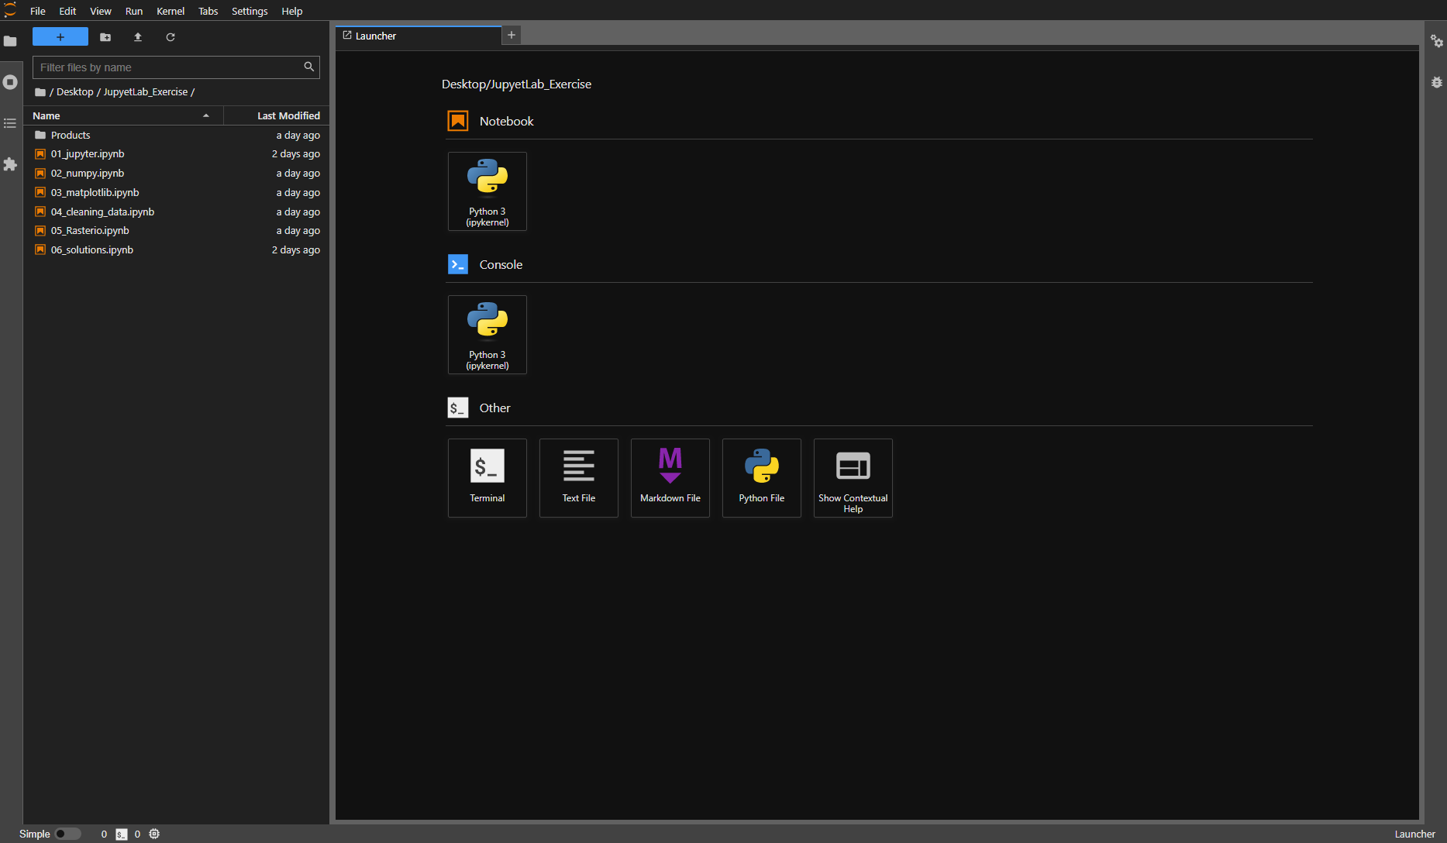

In the exercises, you will be introduced to how to use Jupyter Notebooks as well as some Python libraries that are essential in ML.

Open file “01_jupyter.ipnyb” with double click and start following the instructions. After completing first file, open second one and start with the exercises. At the end of each file there is a small task to complete to determine the material learned. If you have trouble with completing task, you can use file “06_solution.ipynb” as a help (but first try without the help!).

Once you have finished the exercise, take a screenshot with the solution and post the four screenshots in the forum.